Use this same template every day, for every task, throughout all 6 phases. Fill in every field before submitting.
1 | 📋 Intern & Task Details

Intern Name | Mohamed Imthiyas A
Phase / Day | Phase 1/ Day 2
Date | 02/07/2026
Task / Topic Title | Control Flow — Teach Your Program to Decide and Repeat
Time Spent (hrs) | 0.7

2 | 📝 Summary of Work Done
2–4 sentences: what did you build or learn today?
Completed three Python programs to practice control flow concepts. Developed a Grade Checker using conditional statements, a Multiplication Table Printer using loops, and a menu-driven ATM Simulator with balance management, transaction tracking, input validation, and a PIN authentication system. The tasks reinforced the practical use of conditionals, loops, and program flow in interactive applications.

3 | 👣 Steps Followed
List the key steps you completed, in order.
1. Implemented the Grade Checker using if, elif, and else statements.
2. Developed the Multiplication Table Printer using for and while loops with an exit option.
3. Built a menu-driven ATM Simulator with deposit, withdrawal, balance enquiry, and transaction tracking.
4. Tested all programs with different inputs, including valid, invalid, and edge-case scenarios to verify correctness.

4 | 🧩 Challenges Faced & How You Solved Them

No major challenges were encountered. The concepts were straightforward, and each program was tested with multiple inputs to ensure the logic worked as expected.

5 | 💡 Key Learnings
What’s the one thing you understand better now than this morning?
• Understood how conditionals control program execution based on different inputs.
• Learned to use while and for loops for repetitive and menu-driven applications.
• Gained practical experience in combining loops, nested conditions, input validation, and transaction tracking to build an interactive console application.

6 | 🔗 Proof of Work

File(s) / Folder Name | Innolift/Day 2 /grade_checker.py  Innolift/Day 2 / table_printer.py  Innolift/Day 2 / atm_simulator.py
GitHub Repo Link
Screenshot Attached? | 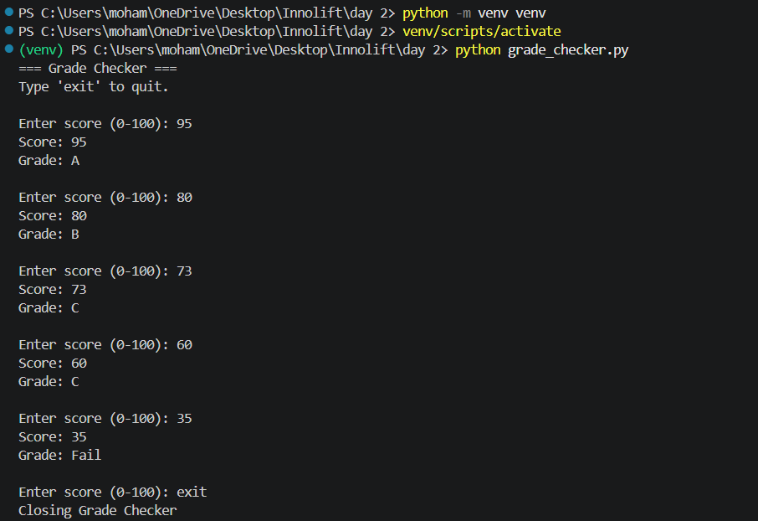  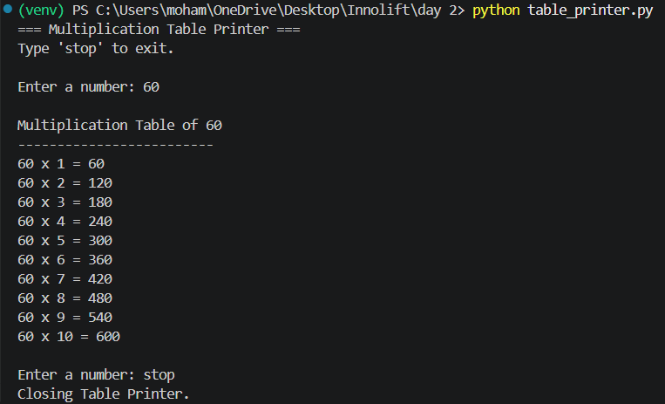  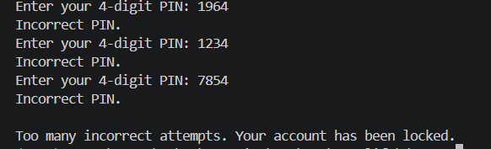  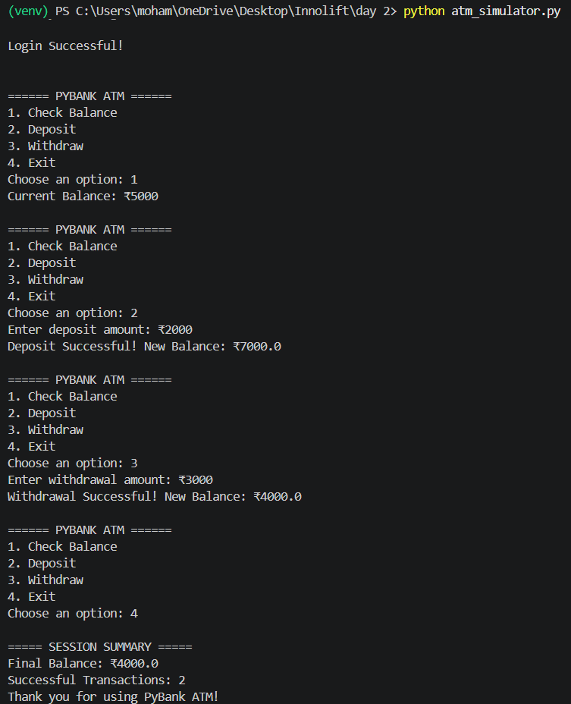
Live/Deployed Link (Later Phase)

7 | ⭐ Self-Assessment

Star Rating | ⭐ ⭐ ⭐ ⭐ ⭐  (circle or fill in stars — 1 = needs help, 5 = fully confident)
Comments | Successfully completed all assigned tasks, including the bonus PIN authentication feature for the ATM Simulator. The programs were tested with multiple scenarios to verify correct functionality and improve confidence with Python control flow concepts.

8 | 🎯 Mentor Feedback (left blank by intern)

Status
Comments

